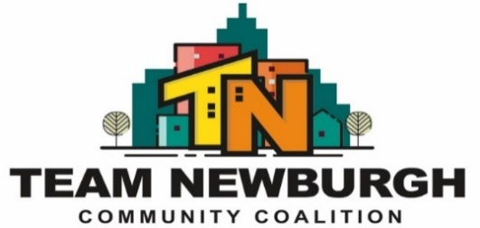
Mission Statement: “TEAM Newburgh will strengthen our community by building relationships and utilizing prevention, education and outreach strategies”
Full Coalition Meeting
Location: Newburgh Recreation Center (401 Washington Street Newburgh, NY)
Date: December 10th, 2025
Topic | Who | Actions/Decisions | Notes:
Welcome/Introductions | Everyone | - Who will be taking meeting minutes today? | The meeting opened with a festive holiday potluck. Members brought dishes to share and contributed non-perishable items to support the Loaves & Fishes Food Drive.  Gratitude was expressed to all partners for their generosity and participation.
- General | Frankie  Erme  Carley (Co-Chair)  Melissa (Co-Chair)  Everyone | - Yearly Recap PowerPoint  - Bingo  - Social Media Video | A presentation highlighted the coalition’s work throughout 2025, including:  Major community events and outreach initiatives  Partner participation levels  Number of community members served  Significant wins and challenges  Preliminary goals moving into 2026  Team Newburgh Partner Bingo Winner: Sam – National Guard Counterdrug Task Force  Festive Sweater Contest Winner: Gianna – Planned Parenthood of Greater New York  Left-Right Partner Game Winner: Anne  Members enjoyed engaging activities to celebrate collaboration and the end of the year.
- Special Population Grant | Dawn  Erme | - Special Pops Updates  - Community Survey update  - Coalition Capacity Survey  - Initiatives for January | November Community Scan  Conducted with 10 participants at the skate park near the Recreation Center.  Items found included: needles, condoms, cannabis-related stickers, alcohol bottles, and other drug-related paraphernalia.  2026 Prevention Initiatives  Planning for a Sticker Shock–style campaign using DoorDash delivery bags distributed through local businesses.  Posters, yard signs, and other signage will be placed in high-traffic youth areas (schools, parks, community centers).  All printed materials will use large, bilingual fonts (English/Spanish).  A youth informational session will be held at a local college campus discussing:  Risks and consequences of underage cannabis use  Violations related to the Social Host Law  Looking ahead to 2026:  Hosting an educational session for Newburgh City Council members, local law enforcement leadership, and the community focused on the importance of compliance checks at cannabis retailers.
- TEAM Newburgh Upcoming Events | Frankie  Melissa | - Reminder TEAM needs more than 1 week notice to participate in partner events.  - Health 1st Holiday Event- Members needed to help table for TEAM  - NFA West Vape Presentation  - Meadow Hill Vape Presentation | Team Newburgh and ADAC will co-facilitate two vaping and edibles education sessions:  NFA West – December 18  Audience: 30 students (grades 9–11)  Activities: icebreakers, Mystery Vape Box, relay race, drug trivia  Presentation: 15–20 minute focused lesson on vaping and edibles  Meadow Hill School – January  Audience: 7th graders in Health Classes (5 sessions) Similar presentation and activities as NFA West
- Outreach & Policy |  | - TEAM will be helping most Wednesdays from 12-3pm for the backpack food program for 240 NECSD students.  - Policy - | Discussion: How would you like to help leadership restructure subcommittees: outreach, substance use, mental health, education and policy.
- Voting Items |  | - Approved Meeting Minutes from November | November meeting minutes were approved by:  Justine (ADAC)  Ralph (Cornerstone)
See you all in the New Year:  Next Meeting  January 14th 2026 | Everyone | Partner Updates / Concerns  1 minute keep it relevant to the month of December & January | Catholic Charities is running Girls Circle – Horizon on the Hudson Launching in January for approximately 20 students in partnership with Horizon on the Hudson. Youth Coalition  Team Newburgh’s Director of Prevention met with the Newburgh Enlarged City School District.  Discussion included:  Launching youth coalitions in all four schools beginning Fall 2026  Hosting one quarterly weekend meeting for all youth coalition members districtwide  Potential for Upstander training to strengthen youth leadership. Review and planning for youth surveys  Next Coalition Meeting:  Wednesday, January 14, 9:30 AM  All partners are welcome.

